**Module 8 - Microservices with Spring Boot 3 and Spring Cloud REST - Get country based on country code**

**Structure:**

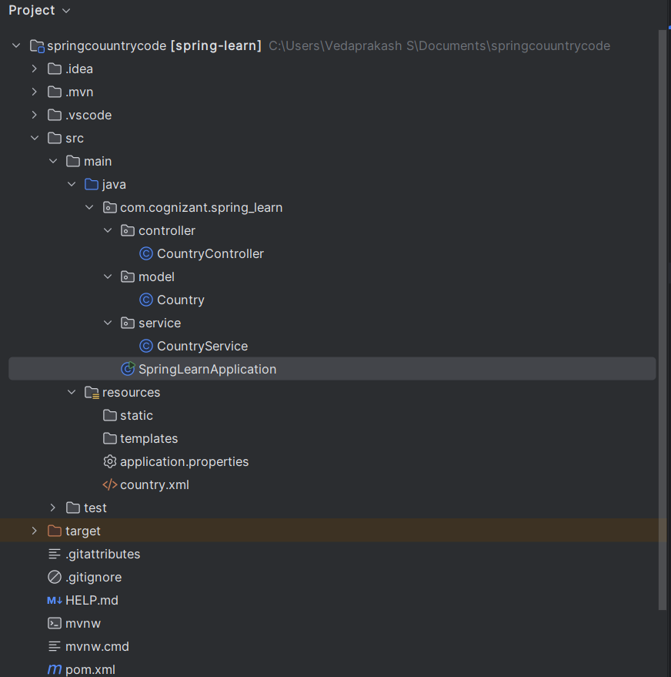

**CountryController.java:**

package com.cognizant.spring_learn.controller;  
  
import com.cognizant.spring_learn.model.Country;  
import com.cognizant.spring_learn.service.CountryService;  
import org.springframework.beans.factory.annotation.Autowired;  
import org.springframework.web.bind.annotation.*;  
  
@RestController  
public class CountryController {  
  
 @Autowired  
 private CountryService countryService;  
  
 @GetMapping("/country/{code}")  
 public Country getCountry(@PathVariable String code) {  
 return countryService.getCountry(code);  
 }  
}

**Country.java:**

package com.cognizant.spring_learn.model;  
  
public class Country {  
 private String code;  
 private String name;  
  
 public Country() {}  
  
 public Country(String code, String name) {  
 this.code = code;  
 this.name = name;  
 }  
  
 public String getCode() { return code; }  
 public void setCode(String code) { this.code = code; }  
  
 public String getName() { return name; }  
 public void setName(String name) { this.name = name; }  
}

**CountryService.java:**

package com.cognizant.spring_learn.service;  
  
import com.cognizant.spring_learn.model.Country;  
import org.springframework.stereotype.Service;  
import org.springframework.context.support.ClassPathXmlApplicationContext;  
  
import java.util.List;  
  
@Service  
public class CountryService {  
 public Country getCountry(String code) {  
 ClassPathXmlApplicationContext context = new ClassPathXmlApplicationContext("country.xml");  
 List<Country> countries = (List<Country>) context.getBean("countryList");  
  
 for (Country c : countries) {  
 if (c.getCode().equalsIgnoreCase(code)) {  
 context.close();  
 return c;  
 }  
 }  
 context.close();  
 return null;  
 }  
}

**SpringLearnApplication.java:**

package com.cognizant.spring_learn;  
  
import org.springframework.boot.SpringApplication;  
import org.springframework.boot.autoconfigure.SpringBootApplication;  
  
@SpringBootApplication  
public class SpringLearnApplication {  
 public static void main(String[] args) {  
 SpringApplication.*run*(SpringLearnApplication.class, args);  
 }  
}

**application.properties:**   
server.port=8085

**country.xml:**

<?xml version="1.0" encoding="UTF-8"?>  
<beans xmlns="http://www.springframework.org/schema/beans"  
 xmlns:xsi="http://www.w3.org/2001/XMLSchema-instance"  
 xsi:schemaLocation="  
 http://www.springframework.org/schema/beans  
 http://www.springframework.org/schema/beans/spring-beans.xsd">  
  
 <bean id="country" class="com.cognizant.spring_learn.model.Country">  
 <property name="code" value="IN"/>  
 <property name="name" value="India"/>  
 </bean>  
  
 <bean id="countryList" class="java.util.ArrayList">  
 <constructor-arg>  
 <list>  
 <ref bean="country"/>  
 <!-- Add more country beans here if needed -->  
 </list>  
 </constructor-arg>  
 </bean>  
</beans>

**pom.xml:**

<project xmlns="http://maven.apache.org/POM/4.0.0"  
 xmlns:xsi="http://www.w3.org/2001/XMLSchema-instance"  
 xsi:schemaLocation="http://maven.apache.org/POM/4.0.0  
 http://maven.apache.org/xsd/maven-4.0.0.xsd">  
  
 <modelVersion>4.0.0</modelVersion>  
  
 <groupId>com.cognizant</groupId>  
 <artifactId>spring-learn</artifactId>  
 <version>0.0.1-SNAPSHOT</version>  
 <packaging>jar</packaging>  
  
 <name>spring-learn</name>  
 <description>Spring Boot Hello World REST API</description>  
  
 <parent>  
 <groupId>org.springframework.boot</groupId>  
 <artifactId>spring-boot-starter-parent</artifactId>  
 <version>3.2.4</version> <!-- You can change to a stable version you're using -->  
 <relativePath/> <!-- lookup parent from repository -->  
 </parent>  
  
 <properties>  
 <java.version>17</java.version> <!-- Or 21 if you're using JDK 21+ -->  
 </properties>  
  
 <dependencies>  
 <!-- Spring Web for REST Controller -->  
 <dependency>  
 <groupId>org.springframework.boot</groupId>  
 <artifactId>spring-boot-starter-web</artifactId>  
 </dependency>  
  
 <!-- Logging with SLF4J & Logback -->  
 <dependency>  
 <groupId>org.springframework.boot</groupId>  
 <artifactId>spring-boot-starter-logging</artifactId>  
 </dependency>  
  
 <!-- Optional: For Testing -->  
 <dependency>  
 <groupId>org.springframework.boot</groupId>  
 <artifactId>spring-boot-starter-test</artifactId>  
 <scope>test</scope>  
 </dependency>  
 </dependencies>  
  
 <build>  
 <plugins>  
 <!-- Spring Boot Maven Plugin -->  
 <plugin>  
 <groupId>org.springframework.boot</groupId>  
 <artifactId>spring-boot-maven-plugin</artifactId>  
 </plugin>  
 </plugins>  
 </build>  
  
</project>

**Output:**

